**Exercise-3 : Stored Procedures**

**Scenario 1:** The bank needs to process monthly interest for all savings accounts.

* + **Question:** Write a stored procedure **ProcessMonthlyInterest** that calculates and updates the balance of all saving accounts by applying an interest rate of 1% to the current balance.
  + **Solution :**

CREATE TABLE SavingsAccount (

account_id NUMBER PRIMARY KEY,

customer_name VARCHAR2(100),

balance NUMBER(10,2)

);

INSERT INTO SavingsAccount VALUES(101, 'Alice', 1000.00);

INSERT INTO SavingsAccount VALUES(102, 'Bob', 2900.00);

INSERT INTO SavingsAccount VALUES(103, 'Charlie', 3000.00);

INSERT INTO SavingsAccount VALUES(104, 'David', 27000.00);

INSERT INTO SavingsAccount VALUES(105, 'Eva', 2400.00);

SELECT * FROM SAVINGSACCOUNT;

CREATE PROCEDURE ProcessMonthlyInterest IS

BEGIN

UPDATE SAVINGSACCOUNT SET BALANCE = BALANCE*1.01;

END;

/

BEGIN

PROCESSMONTHLYINTEREST;

END;

/

SELECT * FROM SavingsAccount;

**Scenario 2:** The bank wants to implement a bonus scheme for employees based on their performance.

**Question:** Write a stored procedure **UpdateEmployeeBonus** that updates the salary of employees in a given department by adding a bonus percentage passed as a parameter.

* + **Solution:**

CREATE TABLE Employee (

emp_id NUMBER PRIMARY KEY,

emp_name VARCHAR2(10),

salary NUMBER(10,2),

department_id NUMBER

);

INSERT INTO Employee VALUES (1, 'Alice', 5000, 10);

INSERT INTO Employee VALUES (2, 'Bob', 6000, 10);

INSERT INTO Employee VALUES (3, 'Charlie', 7000, 20);

INSERT INTO Employee VALUES (4, 'David', 6500, 20);

INSERT INTO Employee VALUES (5, 'Eva', 8000, 30);

INSERT INTO Employee VALUES (6, 'Frank', 5700, 20);

CREATE PROCEDURE UpdateEmployeeBonus (

id_x IN NUMBER,

bonus_x IN NUMBER

) IS

BEGIN

UPDATE Employee

SET salary = salary + (salary * bonus_x / 100)

WHERE department_id = id_x;

END;

/

BEGIN

UpdateEmployeeBonus(20, 10);

END;

/

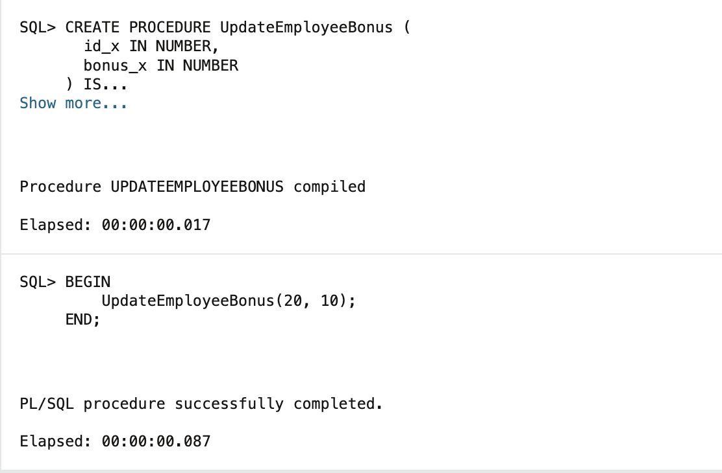

SELECT * FROM EMPLOYEE;

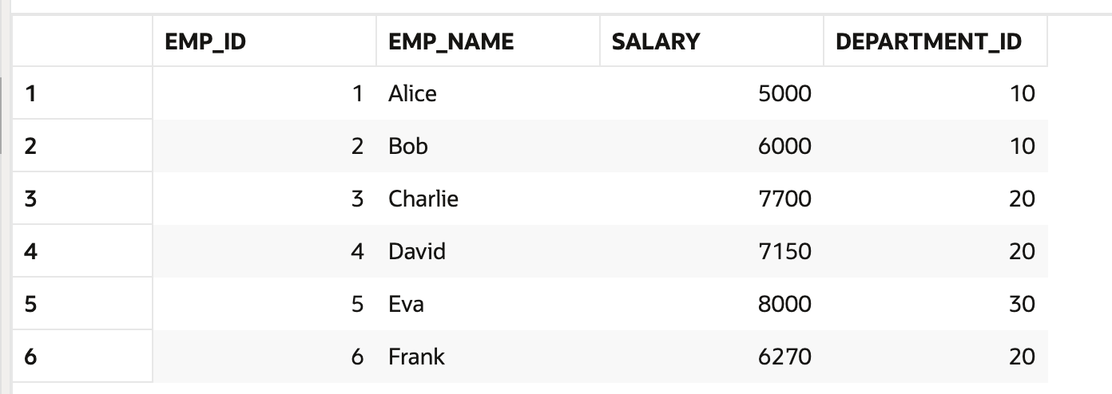

**Scenario 3:** Customers should be able to transfer funds between their accounts.

* + **Question:** Write a stored procedure **TransferFunds** that transfers a specified amount from one account to another, checking that the source account has sufficient balance before making the transfer.
  + **Solution:**

CREATE TABLE Accounts(

account_id NUMBER PRIMARY KEY,

customer_name VARCHAR2(100),

balance NUMBER(10,2)

);

INSERT INTO Accounts VALUES (1001, 'Alice', 5000);

INSERT INTO Accounts VALUES (1002, 'Bob', 3000);

INSERT INTO Accounts VALUES (1003, 'Charlie', 2000);

INSERT INTO Accounts VALUES (1004, 'David', 3500);

INSERT INTO Accounts VALUES (1005, 'Eva', 1700);

CREATE or replace PROCEDURE TransferFunds (

from_account IN NUMBER,

to_account IN NUMBER,

amount IN NUMBER

) IS

BEGIN

UPDATE Accounts

SET balance = balance - amount

WHERE account_id = from_account;

UPDATE Accounts

SET balance = balance + amount

WHERE account_id = to_account;

END;

/

BEGIN

TransferFunds(1001, 1002, 1000);

END;

/

SELECT * FROM ACCOUNTS;

